Mom & Pop’s Planning Document
Team: Boba Tea

Table of Contents:
Scope: 3
Schedule: 7
Gantt Chart: 11
Team Organization: 12
Technical Description: 13
Data Management Plan: 15
Test Plan: 16
Appendix: 20

Scope:
- Log in for customers:
  - Asks for phone number and password
    - Verify number exists
  - If it doesn’t have it in our database, request customer to make account
    - Error prompting for non-existent user
    - Prompt to create an account
  - Create an account link
    - Takes user to create an account page
  - Forgot password link
    - Takes user to password recovery page
  - Offer other sign in or log in options (like Google, Facebook)
- Password recovery page:
  - Prompts user for account email
    - Verify email exists in database
    - If not, prompt error message “no such account with this email exists”
  - Email user a 6-digit code that is randomly generated
  - Prompt user for 6-digit code
    - Verify code is correct
    - If not, prompt “invalid code”
  - If code is correct, prompt user for new password
    - Verify new password passes password rules
  - Update password of user
- Log in for employees:
  - Prompts for username and password
  - Checks in employee database for a matching record
    - If no matching record prompt “speak with manager” error
  - If found, present employee with MFA task
  - Forgot password link
    - Takes users to password recovery page
- Create Customer account:
  - Asks for email and password
    - Verifies email exists
    - Verify password meets length and special character requirements
  - Prompts for user phone number
    - Verifies phone number exists and has a valid format
  - Prompt user for name
  - Send email for confirmation
- Menu page:
  - PDF link for full menu
    - Includes nutrition information
  - Shows small pictures of each category
    - Individual item lets you select toppings, size (if applicable), crust options (if applicable), and other attributes
  - Once an item is configured, it can be added to the cart
    - Updates the cart with number of items and cost (with tax)
- Home/Main page:
  - Branding and Logo display
  - Quick paragraph about us
  - Display menu highlights on front page
    - Sliding screen showing various highlights
    - Order now link on each sliding page
  - Prompt users to sign up to begin ordering
- About Page:
  - Quick explanation of the restaurant
  - Contact us information providing restaurant email, phone number, address
  - Links to social media pages
- Merch Page:
  - List of various merchandise that you can add to your cart
    - Each item can be configured for size and color
    - Can be added to cart
- Cart Page:
  - Display current list of items in the cart
  - Allow editing and removal of cart contents
  - If cart is not empty, show calculated total with tax and provide a button to checkout
- Checkout Page:
  - Enter order type (delivery or pickup)
  - Provide entire total and present the user to select the payment method
    - If paying with card
      - If payment method is not present for user account, add one
    - If paying with cash
      - Move on to finalizing order
  - Let customer use reward points if available and eligible
  - Place order button when all necessary fields are populated
    - Verify payment method is present
    - Verify address is valid and within range
    - Send confirmation email
  - If delivery, prompt user for specific delivery instructions/comments
- Customer Account Page:
  - Shows users their previous orders
    - Option to reorder the same items
  - Settings sub header
    - Customer can delete account
    - Customer can update their email or password
  - Show customer reward points
  - Information sub header
    - Customer can add, or remove payment information
    - Customer can add, edit, or remove their address
    - Customer can edit name
- Receipt Manager:
  - Create new receipts for customer orders
    - Customer phone number and name
    - List items purchased
    - Order type (pickup or delivery)
    - Amount due
    - Payment type (cash or card)
  - Recall past order receipts
- Employee Dashboard:
  - Provides info on current orders
  - Provides information on inventory numbers
  - Timesheet manager
    - Clock in/Clock Out
    - Request Time Off
    - Show PTO
  - Announcements
  - Shift Schedule
  - View special tasks
  - Settings & Preferences
    - Address modification
    - Emergency Contacts
    - Direct Deposit Information
  - View paystubs
- Manager Dashboard:
  - Provides info on current orders
  - Provides information on inventory numbers
    - Modify inventory numbers
  - Timesheet manager
    - Clock in/Clock Out
    - Request Time Off
    - Show PTO
    - Modifying Employee time sheets
  - Announcements
    - Create new announcements
      - Select announcement data and display time
  - Shift Schedule
    - Modify Shift Schedule
  - View special tasks
    - Assign special tasks to individual employees
  - Settings & Preferences
    - Address modification
    - Emergency Contacts
    - Direct Deposit Information
  - View paystubs
    - Approve Paystubs
  - View Employee Directory
    - Add or remove employees
- Customer Record:
  - Name
  - Address
  - Phone Number
  - Email address
  - Payment Information
- Employee Record:
  - Name
  - Address
  - Phone Number
  - Email address
  - Payment Information
  - Hourly Rate/Salary
  - Employee ID

Schedule:
Schedule < use a work breakdown structure to layout the project tasks, start/finish, planned/actual and status >
Task ID | Work breakdown structure | Planned start | Planned finish | Workload-planned | Workload - actual | Progress (%complete)
1 | Log in page | 9/22/2025 | 9/29/2025 | T: 12 hrs  Brice, Vincent | Null | Null
1.1 | Request for number and verification | 9/22/2025 | 9/29/2025 | T: 8 hrs  Brice, Vincent, Chris | null | Null
2 | Password recovery page | 9/29/2025 | 10/6/2025 | T: 8 hrs | Null | Null
2.1 | Prompting user for email and using it to verify password | 9/29/2025 | 10/6/2025 | T: 4 hrs  Vincent  Natalie | Null | Null
3 | Log in for employees | 10/6/2025 | 10/13/2025 | T: 5 hrs  Brice  Chris | Null | Null
4 | Create customer page | 10/13/2025 | 10/20/2025 | T: 13 hrs  Natalie  Chris  Brice | Null | Null
4.1 | Prompting user for information and to create customer | 10/13/2025 | 10/20/2025 | T: 3 hrs  Natalie  Vincent | Null | Null
4.2 | Quick links for earlier pages | 10/13/2025 | 10/20/2025 | T: 7 hrs  Chris  Vincent | null | null
5 | Home page | 10/20/2025 | 10/27/2025 | T: 4 hrs  Vincent  Chris  Brice | Null | Null
6 | Menu page | 10/20/2025 | 10/27/2025 | T: 3 hrs  Natalie  Brice | Null | Null
6.1 | About page and quick links | 10/20/2025 | 10/27/2025 | T: 5 hrs  Natalie  Brice | Null | Null
6.2 | Merch page | 10/20/2025 | 10/27/2025 | T: 5 hrs  Natalie | Null | Null
6.3 | Quick links from home page to other various pages | 10/20/2025 | 10/27/2025 | T: 7 hrs  Brice  Vincent | Null | Null
6.4 | Sliding menu highlights on the main page | 10/20/2025 | 10/27/2025 | T: 9 hrs  Natalie  Chris | Null | null
7 | Cart page | 10/27/2025 | 11/3/2025 | T: 4 hrs  Vincent  Chris | Null | Null
7.1 | Linking and making the cart functional | 11/3/2025 | 11/3/2025 | T: 7 hrs  Brice  Natalie | Null | Null
8 | Checkout page | 11/3/2025 | 11/10/2025 | T: 15 hrs  Natalie  Brice | Null | Null
8.1 | Verifying payment method, address, and confirmation email | 11/3/2025 | 11/10/2025 | T: 20 hrs  Brice  Chris  Natalie  Vincent | Null | null
9 | Customer account page | 11/10/2025 | 11/17/2025 | T: 7 hrs  Brice | null | Null
10 | Receipt manager | 11/10/2025 | 11/17/2025 | T: 9 hrs  Vincent  Natalie | Null | Null
11 | Recall past orders | 11/10/2025 | 11/17/2025 | T: 3 hrs  Brice  Chris | Null | Null
12 | Employee dashboard | 11/17/2025 | 11/24/2025 | T: 8 hrs  Natalie  Chris | Null | Null
12.1 | Provides info on current orders | 11/17/2025 | 11/24/2025 | T: 9 hrs  Vincent  Brice | Null | null
12.2 | Shows inventory numbers | 11/17/2025 | 11/24/2025 | T: 5 hrs  Natalie  Brice | Null | Null
12.3 | Timesheet | 11/17/2025 | 11/24/2025 | T: 8 hrs  Chris  Vincent | null | Null
12.4 | Announcement | 11/17/2025 | 11/24/2025 | T: 3 hrs  Natalie | Null | null
12.5 | Shift schedule | 11/17/2025 | 11/24/2025 | T: 8 hrs  Vincent  Chris | Null | Null
12.6 | View tasks | 11/17/2025 | 11/24/2025 | T: 4 hrs  Natalie  Chris | Null | null
12.7 | Settings and preferences | 11/17/2025 | 11/24/2025 | T: 7 hrs  Brice  Vincent  Chris | Null | Null
12.8 | View paystubs | 11/17/2025 | 11/24/2025 | T: 6 hrs  Natalie  Chris | Null | Null
13 | Manager dashboard | 11/24/2025 | 12/1/2025 | T: 7 hrs  Natalie  Brice | Null | Null
13.1 | Info on current orders | 11/24/2025 | 12/1/2025 | T: 9 hrs  Natalie  Vincent  Chris | Null | Null
13.2 | Inventory numbers | 11/24/2025 | 12/1/2025 | T: 10 hrs  Natalie  Brice  Chris | Null | Null
13.3 | Modify inventory numbers | 11/24/2025 | 12/1/2025 | T: 5 hrs  Brice  Vincent | Null | Null
13.4 | Timesheet manger | 11/24/2025 | 12/1/2025 | T: 3 hrs  Brice  Vincent  Chris | Null | Null
13.5 | Create new announcements | 11/24/2025 | 12/1/2025 | T: 9 hrs  Chris | Null | Null
13.6 | Modifying shift schedule | 11/24/2025 | 12/1/2025 | T: 13 hrs  Natalie  Brice  Vincent  Chris | null | Null
13.7 | Viewing and assigning special tasks | 11/24/2025 | 12/1/2025 | T: 3 hrs  Natalie  Brice  Vincent  Chris | Null | Null
13.8 | View and approve paystubs | 11/24/2025 | 12/1/2025 | T: 10 hrs  Natalie  Chris | Null | Null
13.9 | Employee directory | 11/24/2025 | 12/1/2025 | T: 9 hrs  Chris  Natalie | null | null
14 | Customer record | 11/24/2025 | 12/1/2025 | T: 8 hrs  Chris  Brice | Null | Null
15 | Employee record | 11/24/2025 | 12/1/2025 | T: 3 hrs  Natalie  Brice | null | Null

Gantt Chart:
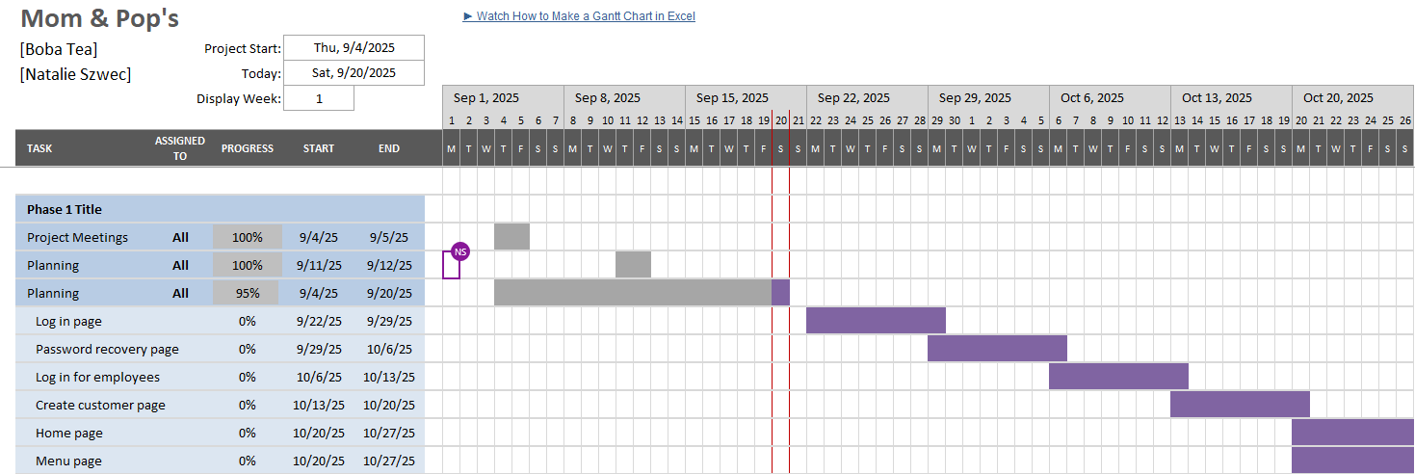

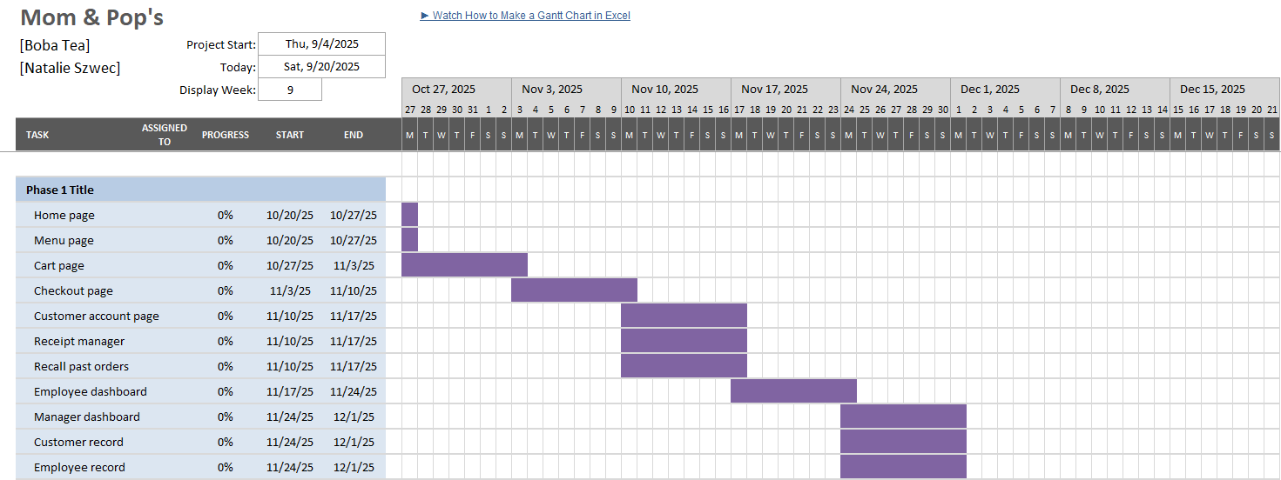

Team Organization:

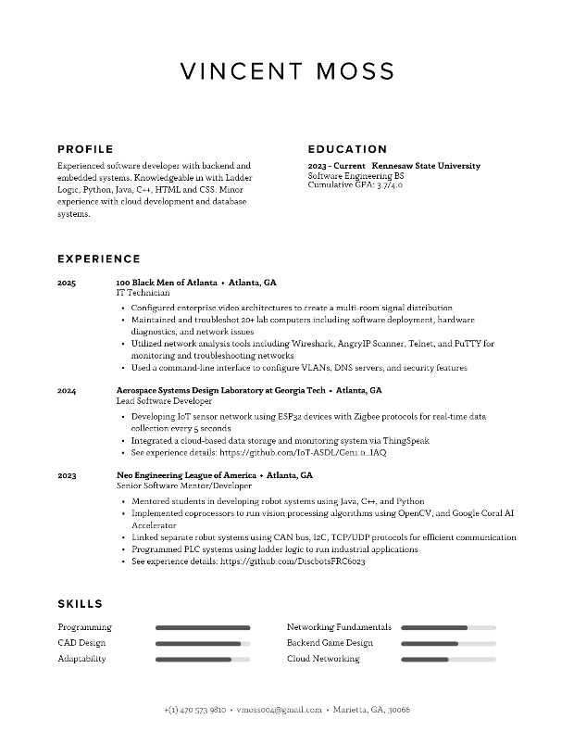
Natalie Szwec - Team Manager Vincent Moss - Developer
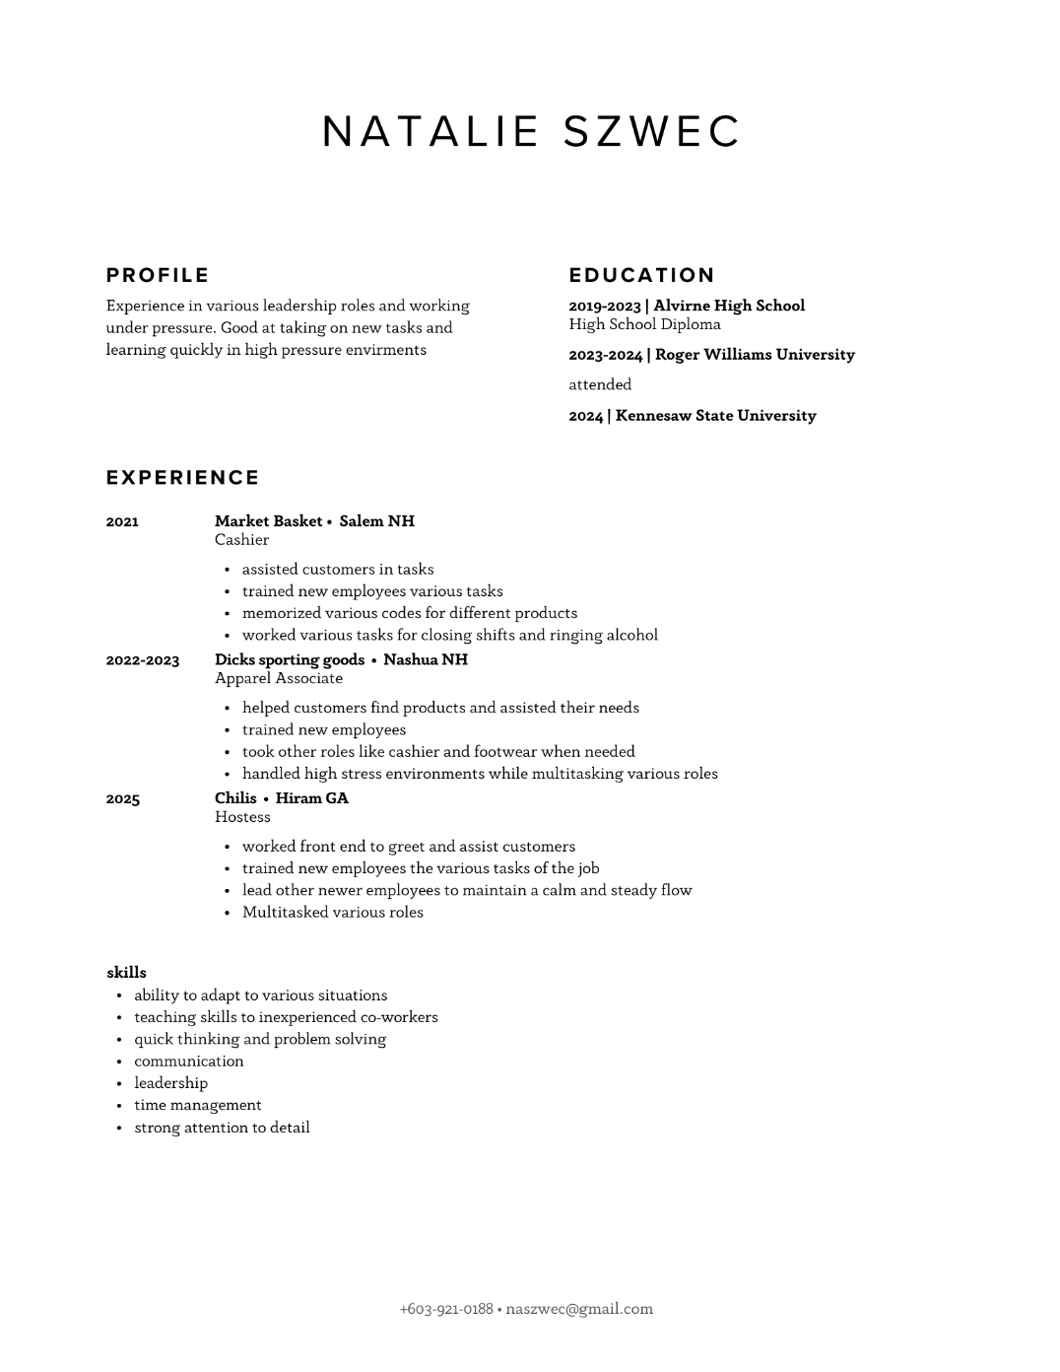

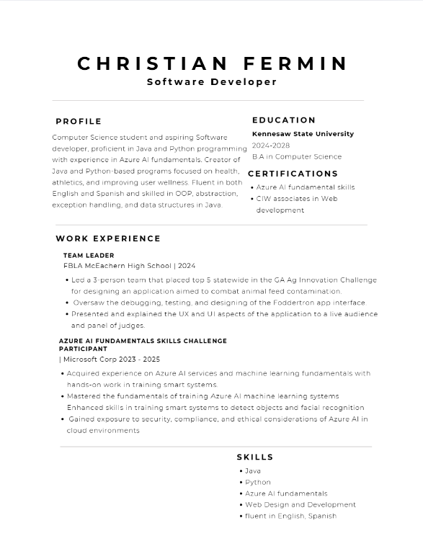
Christian Fermin - Tester Brice Polk – Developer
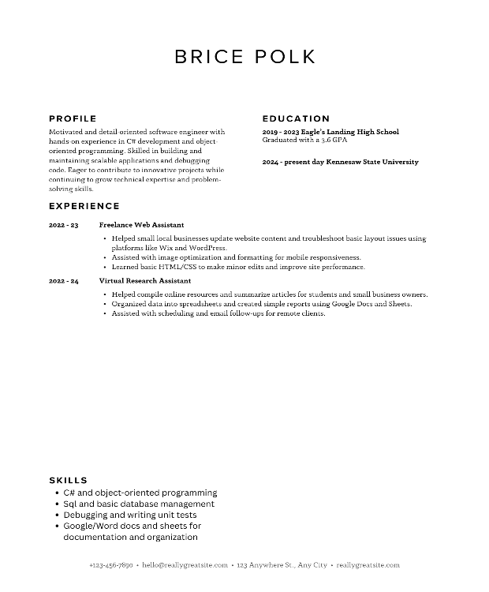

Technical Description:
Hardware:
- Raspberry PI running web server (represents real server or potentially cloud infrastructure)
- Main restaurant computer that employees and managers can access
- In terms of the customer side, any device with a web browser
Software:
- Web server software - a LAMP stack or something similar will be required to host the website on the Raspberry PI or cloud infrastructure.
- Front end Framework - Some combination of JavaScript, CSS, and HTML5 will be used for the interactive web pages
- Back end Framework – A lightweight back end framework will manage user authentication, session management, and order processing
- Database - A MySQL database will be used to store customer data, menu items, orders, and user credentials.
Development Restrictions:
- Security Standards - Use a simple username and password for authentication. Store the password using a basic hashing method.
- Privacy Standards - The app will comply with data privacy regulations to protect customer data and payment information.
- Strict time limits
User Interface for Pages:
- Home:
  - A list of menu items that contain an order now button
  - Site header with drop down menu at the left and a cart icon at the right
  - When the cart icon is hovered over, a small drop-down menu will show the number of items in the cart
  - Hovering over the carrot menu will show the sub-pages of the website
  - A page footer that provides important contact and compliance information
- Menu:
  - Scrolling list of menu items (Each has a picture and a small description)
  - When a menu item is clicked, it will open a pop-up that provides users with multiple choices of toppings, sizes, and cuts (when applicable)
  - Below the item pop-up would be an add to cart button
- Cart:
  - Clicking on the icon will open the cart page
  - In the cart page is a full list of everything added to the cart
  - Each list index contains a remove button at the right, and a quantity drop down menu
  - At the bottom of the page is the “continue with checkout” button
  - Depending on order type, text field for delivery instructions to the left of checkout button
- Login:
  - Center Section:
    - There is a username and password field in the center of the screen
    - Following login credentials is an option to sign in with Google
    - Under is a submit button for login credentials
  - Outside of center section is a link to forgot password and a separate link for creating new user account
  - Creating New User Login:
    - Form for users to input their name, phone number, email address, and password
    - Central create account button under text fields
  - Forgot Password:
    - Text field for user to input account phone number or email address
    - Button labeled “send reset code”
    - Text field for security code
    - If security code is correct, then we open the “new password” text field

Data Management Plan:
Manager:
- Can view and modify all pages
- Main/Landing Page:
  - Can modify the current highlights of the menu
- Menu Page:
  - Remove, add, or edit menu items
  - Can modify item descriptions, graphics, and modifications
- About Page:
  - Update business description and graphics
  - Can update restaurant contact information
- Merchandise Page:
  - Add, remove, or modify merchandise items
- Dashboard:
  - Access employee names, emails, phone numbers, and employee IDs
  - View and modify full inventory
  - View, modify, and cancel current order records
  - Create, remove and edit customer from customer directory
  - View, and edit time sheet information for employees
  - Create, view and remove announcements
  - Can edit and view shift schedule
  - Create, edit, and remove employee specific tasks
  - Can view, and edit paystubs
  - Create and remove employees from directory
  - Create, edit, and remove order records
  - Can view and modify receipt records
Employee:
- Can view all pages
- Dashboard:
  - Access and modify their employee information
  - View and edit customer order items
  - Can view customer order cost
  - View customer name and phone number
  - Can view the shift schedule
  - View announcements
  - View their individual timesheet
Customer:
- Can view the main, cart, menu, about, and merch pages
- Dashboard:
  - View, and update their own information
  - Add, remove, and modify their own payment data
  - Customers can view their previous orders and receipts

Test Plan:
The application will be tested using software such as visual studio code. A report will be written regarding all key features of the application including how the log-in screen is presented to the user and if it executes the appropriate actions (verifying a user’s account, storing a user’s account, prompting a user to provide their info, etc.)

The criteria for running tests on the application will be determined by these requirements:
- Meeting all test cases
The main test cases for the application are based on the different features of the app. Below are the following test cases for each key feature of the program.

- Login:
Can a user successfully log-in without any issues
Can a user’s log-in information be stored?
Can a user’s account be verified via phone or email?
If the user logs in with incorrect credentials, does an error message pop up
If the incorrect log-in information is detected, will the user be able to try again?
Does a user receive a confirmation message for their email?

- Ordering:
Can a user add items to their cart
What options does the user have to order? Can they do delivery or pickup?
How does the user want to be notified of their order? Message or email?
Can the user track the status of their delivery order?
Will the user receive a confirmation message via text or email that their order has been prepared and is ready to be delivered or picked up?
Can a user cancel their order ahead of time before the delivery driver arrives?

- Payment options:
What payment options will be accepted? Credit card, debit card, Apple pay, etc.?
Will the application check if the payment option has enough money to cover the cost of the item being ordered
Will the user receive a virtual receipt showing the amount spent as well as their order.

- Accounts:
Employees should be able to log in with their own credentials
Managers should be able to log in with their managerial credentials and have access to seeing inventory checks, rate of deliveries, and monthly earnings
Employees should be able to view orders in the queue, the time the order was confirmed, and the address for the customer selecting delivery as their service of choice.
Employees should also be able to see when an order was placed to prepare for pickup.
Employees should also be allowed to see inventory checks within the shop.

To ensure that our application runs flawlessly, we are going to do verification testing in which our developers will look at the program and see if its functionality matches the criteria we are looking for when designing this program. Each of the major requirements shown above should be executed by the program, and if any errors or bugs persist then our team will work on patching those issues to ensure that customers are easily placing orders, tracking their orders, and being able to have those orders delivered or picked up by them. Our program should make sure that the process of placing an order, paying, creating an account as a customer, accessing the account as a customer or employee/manager, and viewing order details as an employee/manager should be a seamless process so both parties can successfully complete with their tasks.

Error conditions:
- Login errors:
If a user enters the incorrect log-in information, they will be prompted to try again after a limited number of attempts. After their limit is reached, the user will be asked to enter their email or phone number to gain access to their password. The user will then also have the option to change their password if they wish. The new password must be saved in the system for future use, and the user should be able to save all their log-in credentials on their app or browser.

- Placing an order:
A user cannot check out with an empty cart, if they do so by mistake, they should be prompted to add something to their cart first.
A user should also not place a delivery order if they do not enter all the required information such as their address and zip code alongside their account information being their email, phone number, and log-in credentials (username/email and password)
If a user tries to place a pickup order but does not enter their zip code, they should not be able to place this order until they select the nearest location to them by entering their zip code. An error message should be prompted, and they should return to a map asking them to enter their zip code to find the nearest location.

- Payment:
A user should receive a message if their card declines in the moment of checkout. They should be prompted to enter a different form of payment or be allowed to cancel their order and exit the application.
If a user orders an additional item unintentionally, they should be able to delete that item from their order immediately after placing it, and receive a refund. A user can only do this within 4 minutes of placing the order.

Method of testing:
Our team will employ the following testing methods during our project:
Verification testing: Each developer will actively be testing the functionality of the app and if it executes the correct actions corresponding to the log-in, account creation, ordering, and payment features. We will use verification testing to ensure that we are building the most optimal and efficient program for both customers and employees alike to use.
Unit testing: Since our model is delicate, any misplaced order or severe error while a customer is paying could be detrimental to the progress and integrity of our company and its project. Therefore, each individual method, each feature that the main aspects of our program should have must be tested to ensure that there are little or no errors at all. Examples of when we will implore unit testing include but are not limited to testing all the features of when a user logs in, forgets their log-in credentials, when an employee logs in with their credentials and what is presented to them. What payment methods are available to a user and what message is shown to a user if their card declines. The order options a user can choose from as well as any appropriate error messages in the event that a user decides to place a pickup or delivery order without entering their address or zip code.

Preventing unauthorized access
The following precautions will be taken to prevent unauthorized access in our program:
- Users:
Customers can only track their own order history, they cannot have access to anyone else’s
Their passwords are encrypted, and 2-step verification is used when they create their account
There is a max number of log-in attempts once they surpass 6 attempts they will be sent an email asking them to enter a code sent and then to create a new password.

- Payment :
Payment is securley encrypted, credit card information is never stored permanently.
Employees and managers do not have access to a customer’s credit/debit card information.

Appendix:

- Natalie:

- Brice:

- Christian:

- Vincent:
